CLDPROP Product Version 1.1 Change Summary
CLDPROP Version 1.1 reprocessing began in August 2019 in response to an issue with the cloud optical properties (COP) thermodynamic phase algorithm (algorithm details in the CLDPROP User’s Guide, Section 4.1.2) yielding spurious liquid cloud results. Algorithm changes are limited solely to the phase algorithm, and impacts are only on the COP phase results and downstream optical properties retrievals (COT, CER, CWP) and uncertainties.
The COP phase algorithm for CLDPROP is a modified version of the C6/C6.1 MOD06 COP phase algorithm that employs a voting scheme consisting of numerous tests based on the IR thermodynamic phase results [Baum et al., 2012], cloud top temperature retrievals, and dual phase spectral CER retrievals (full algorithm details are provided in Marchant et al. [2016] and Section 2.4 and Appendix E of the MOD06 C6/C6.1 User’s Guide [Link 3]). For CLDPROP Version 1.0, this algorithm was implemented without a key cold cloud sanity check that in C6 MOD06 overrides an undetermined phase or ambiguous liquid phase result provided that the IR phase indicates an ice cloud and that the cloud is cold (CTT<240K) with the reported cloud top property solution provided by the CO₂-slicing technique (cloud top solution method being an indicator of high-altitude clouds). Because VIIRS does not have IR channels in the 13µm CO₂ absorption region that are required for the CO₂-slicing approach, and the C6 MOD06 cloud top algorithm has been replaced in CLDPROP by the ACHA cloud top retrieval (see Section 3.1.2) that uses only the 8.5, 10.8, and 12µm IR window channels, the heritage cloud top solution method information (CO₂-slicing vs IR-window) is unavailable in CLDPROP and the cold cloud sanity check was outright removed from the COP phase algorithm.
The removal of the cold cloud sanity check had unintended consequences, namely spurious liquid phase clouds around the edges of otherwise cold, ice phase clouds. An example from Aqua MODIS is shown in Figure 1, where the red arrow in the CLDPROP V1.0 plot (bottom row, center panel) indicates a region of liquid phase where retrieved cloud top temperature (top row, right panel) is less than 240K. In these cases, the spectral CER tests, which are in fact thresholds applied to ice phase CER retrievals, indicated liquid clouds because the ice CER was smaller than the threshold for liquid phase results. Thus the CER tests outvoted the cloud top temperature test and a liquid phase result for found. This in turn yielded a discontinuity in aggregated ice phase CER statistics exactly at the ice phase CER thresholds used in the spectral CER tests (20µm for ice CER retrievals from the 1.6 and 2.xµm channels, and 15µm for ice CER retrievals from the 3.7µm channel). This discontinuity is shown by the monthly (February 2014) Aqua MODIS 2.1µm CER retrieval histograms in Figure 2 (top panel).
For CLDPROP Version 1.1, the cold cloud sanity check has been restored, albeit in modified form, in the COP phase algorithm. In the event of an undetermined or ambiguous liquid phase result, an ice phase decision is now forced if the cloud top properties phase indicates ice and the cloud top temperature is less than 240K or, for optically thick clouds (COT>40), if either of these conditions are met. The impact of this sanity check on granule-level phase results is shown in the bottom right panel of Fig. 1, where the CLDPROP COP phase better matches that of MYD06 (bottom row, left panel). The impact on monthly ice phase CER statistics is shown in the bottom panel of Fig. 2, where the discontinuity at 20µm is no longer evident.
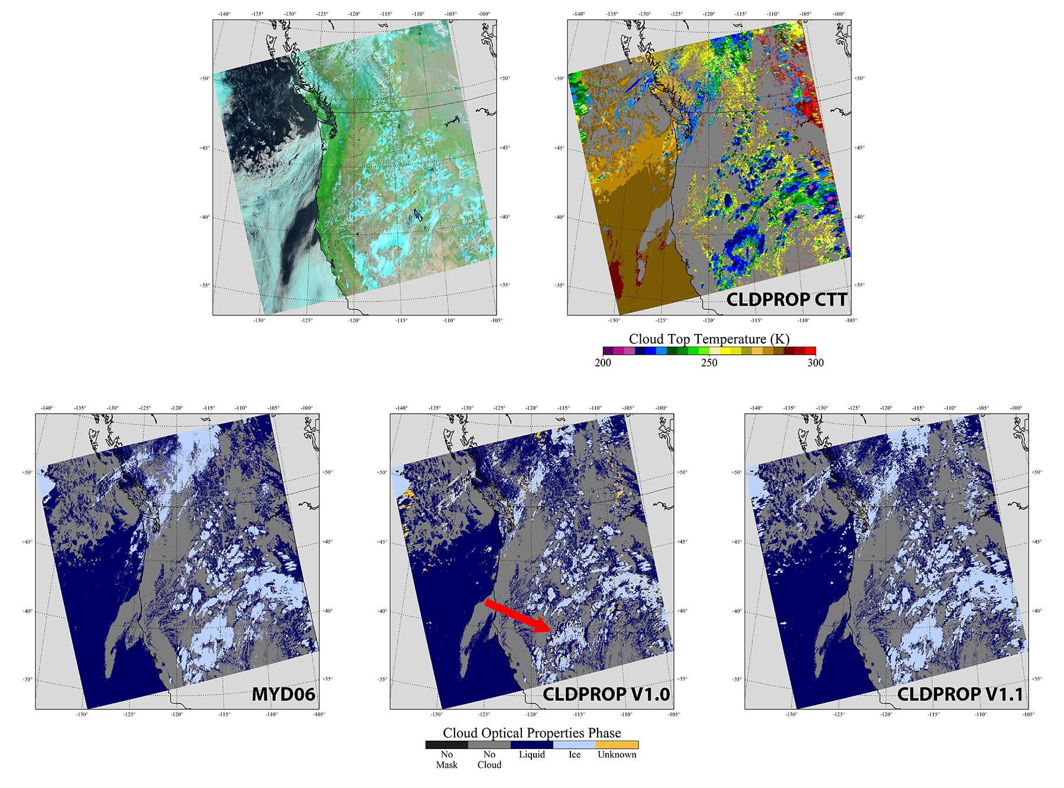
Figure 1. Example Aqua MODIS granule imagery (1 June 2019, 2100UTC) illustrating the spurious liquid phase clouds in the CLDPROP Version 1.0 cloud optical properties phase (red arrow, bottom row center panel). The cloud optical properties phase results from C6.1 MYD06 (bottom row, left panel) and CLDPROP Version 1.1 (bottom row, right panel), are also shown. The spurious liquid clouds are correctly identified as ice in V1.1.
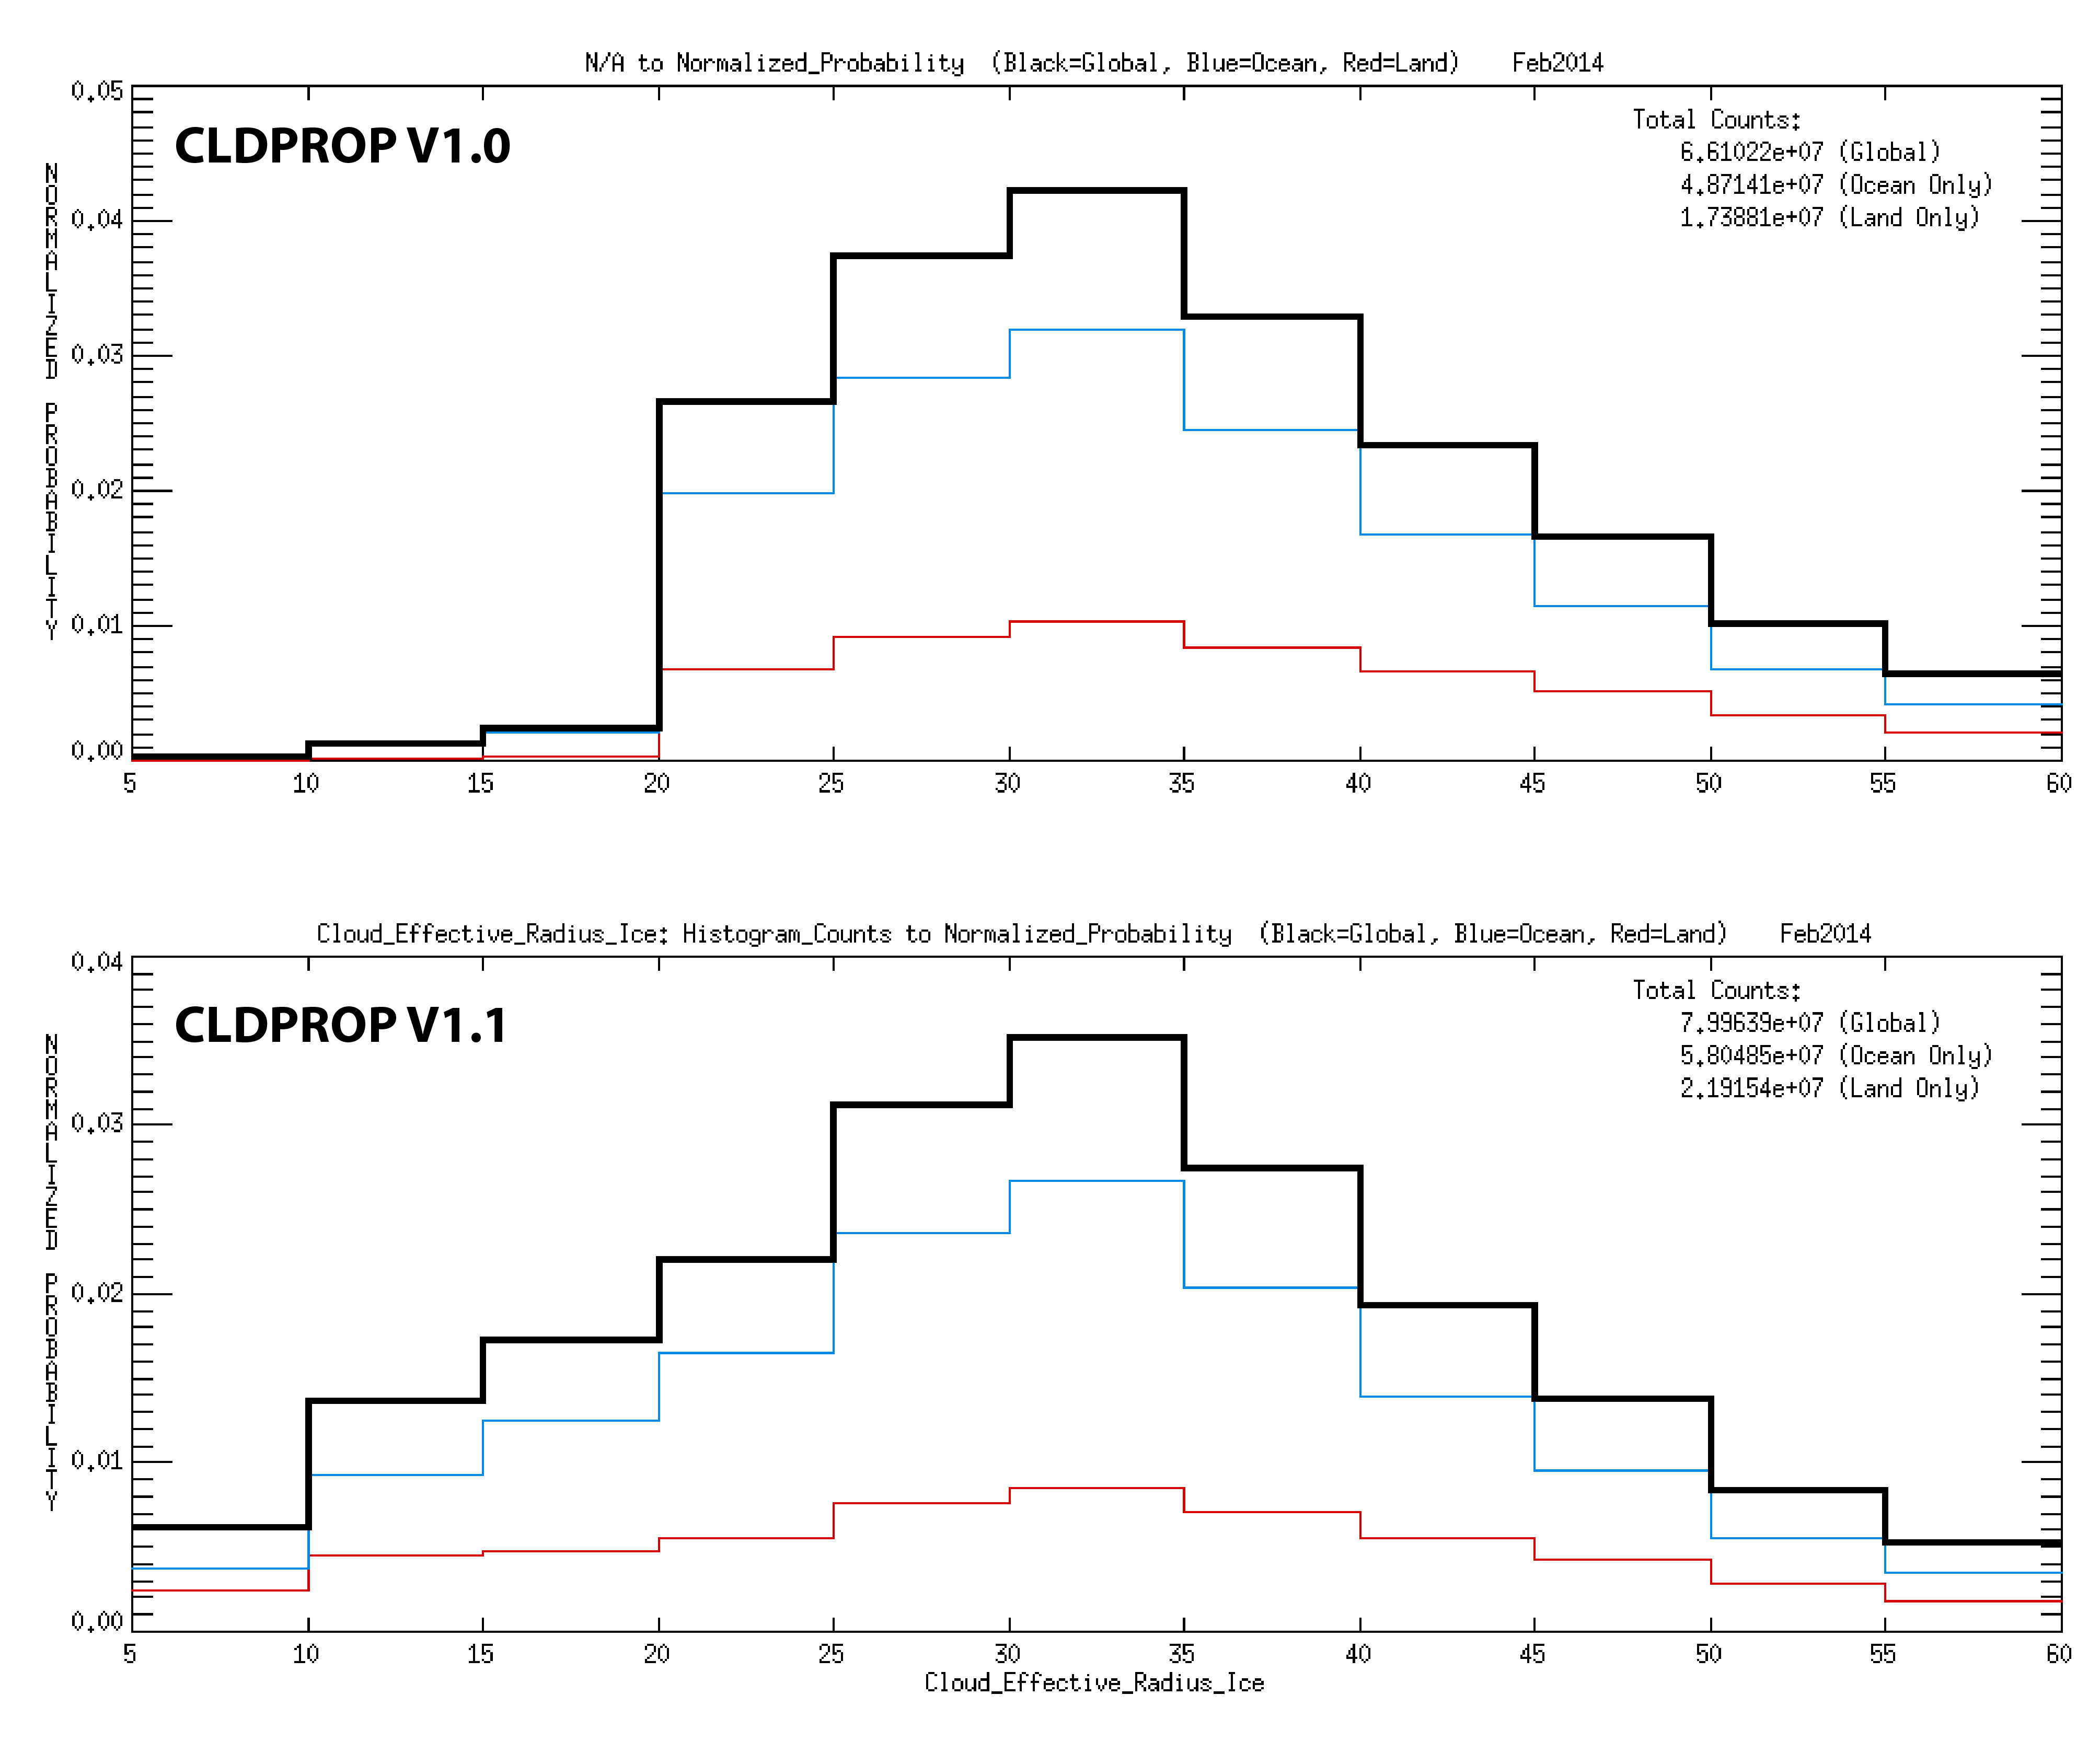
Figure 2. Monthly (February 2014) histograms of Aqua MODIS CLDPROP ice phase 2.1µm CER retrievals from Version 1.0 (top panel) and Version 1.1 (bottom panel) after restoring the cold cloud sanity check in the COP thermodynamic phase algorithm.

